**LAPORAN UAS PCD**

**KELOMPOK 5**

Anggota kelompok :

1. Mikael Rivaldo (312210378)
2. Rafi Maulana Firdaus (312210382)
3. Ricky alfian saputra (312210279)
4. Dimas adi nugraha (312210409)

Mendeteksi warna menggunakan *K-MEANS CLUSTERING* menggunkan foto berikut :

Foto 1

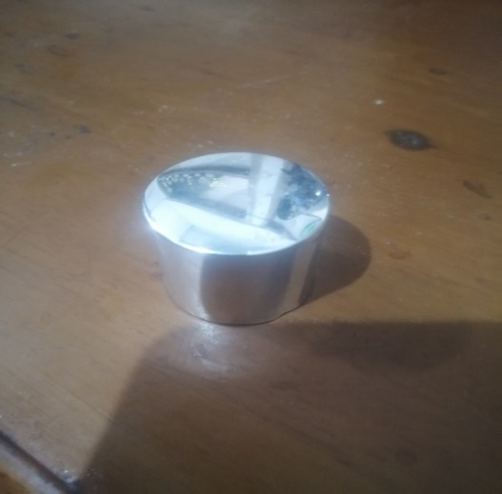

Foto 2



Foto 3

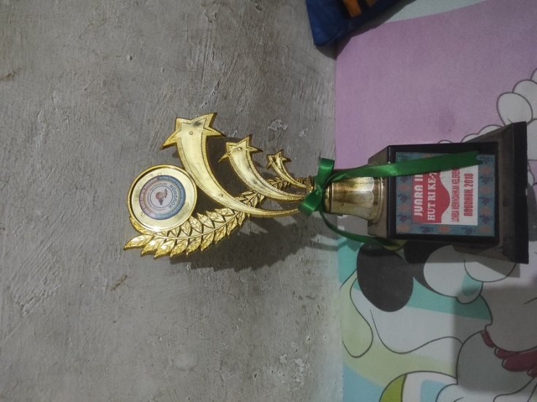

Foto 4

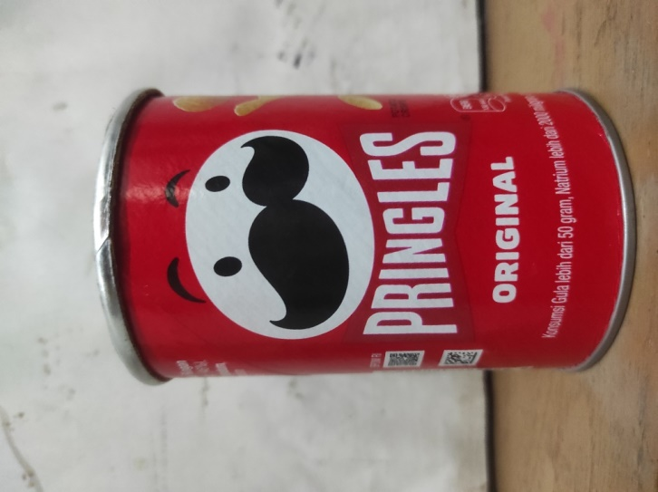

|  |  |  |  |  |
| --- | --- | --- | --- | --- |
| Metadata | Foto 1 | Foto 2 | Foto 3 | Foto 4 |
| Dimensions | 3840 x 5120 | 1317 x 2632 | 3472 x 4640 | 34720 x 4640 |
| Width | 3840 | 1317 | 3472 | 3472 |
| Height | 5120 | 2632 | 4640 | 4640 |
| Horizontal reso | 96 dpi | 72 dpi | 72 dpi | 72 dpi |
| Vertical reso | 96 dpi | 72 dpi | 72 dpi | 72 dpi |
| Bit depth | 24 | 24 | 24 | 24 |
| Color reps | sRGB | sRGB | sRGB | sRGB |